Manx Farmland Birds Recovery Group

Annual Report 2024

Executive Summary

- 2024 was the first full calendar year of work by the Manx Farmland Birds Recovery Group which was established in April 2023.
- The membership of the group includes farmers, conservationists and ornithologists from Manx Wildlife Trust, Manx BirdLife, Manx Ornithological Society, Curraghs Wildlife Park and our farming community.
- The work of the group is funded by donations from individuals and organisations.
- The group, its finances and equipment are housed within Manx Wildlife Trust under the Action for Wildlife initiative.
- Robert Fisher was employed by Manx Wildlife Trust as the Farmland Birds Recovery Officer throughout the year.
- Priorities for Robert’s work in 2024 were:
  - Tree Sparrow
  - Curlew
  - Lapwing
  - Chough
  - Barn Owl
  - Engagement
  - Birds which utilise winter stubbles
- The work of the group was expanded considerably in the autumn via a collaboration with the Curraghs Wildlife Park who have agreed, through their Conservation Fund, to support an initial two years’ worth of work relating to Barn Owl conservation.
- A significant private donation allowed for the purchase of a 4WD Suzuki Jimny for the work of the group, with Manx Wildlife Trust also providing a trailer.

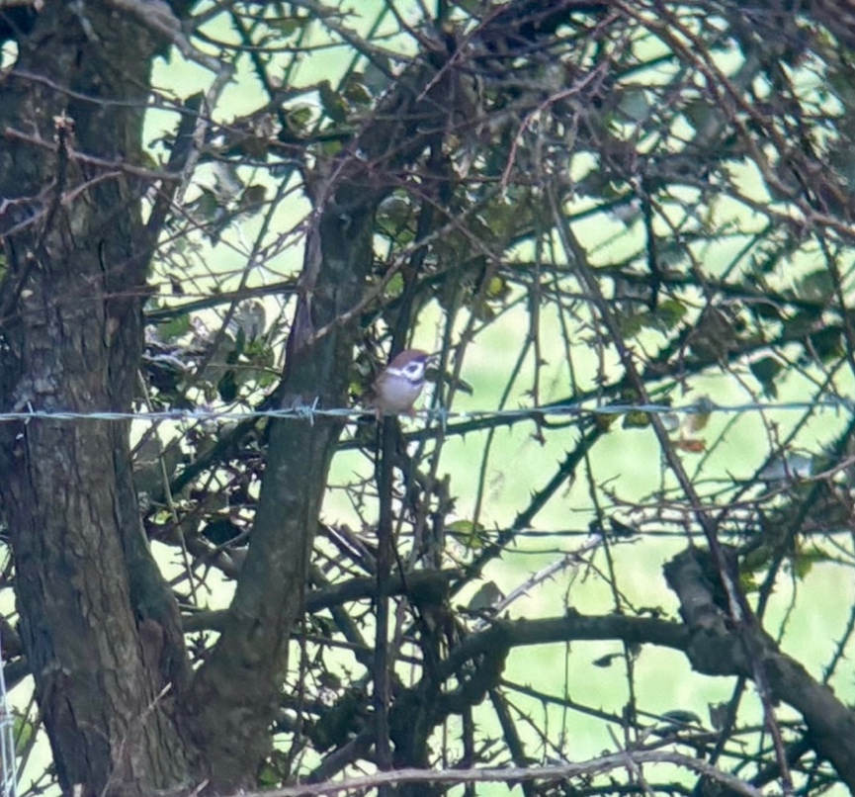
Figure 1 - Tree Sparrow at Ballawhetstone, Arbory, 16th December 2024. © Robert Fisher
Tree Sparrow - Jallyn ny Miljyn

Tree Sparrow are a red-listed, Schedule 1 (specially protected) species which has undergone a significant decline of its population and range on the Island since the turn of this century. The species is our most critically endangered Manx bird and is now considered to be at imminent risk of extirpation, even with dedicated conservation efforts. Through the work of this group, the species is now a Biodiversity Action Plan priority species.

During winter of 2023/24 a high count of 14 individual over-wintering Tree Sparrow was recorded at Ballawhetsone, Arbory during targeted bird ringing. This was the only known Manx over-wintering site for both winters of 2023/24 and 2024/25 (up to time of writing, mid-January 2025). During March 2024, individuals dispersed from Ballawhetstone, presumedly to their breeding areas elsewhere on the Island. At least one pair remained near to the Ballawhetstone site, successfully fledging at least two young during a cold, wet and generally miserable spring and summer, which resulted in poor productivity for most species. There were no other breeding records for the Island in 2024. At Ballawhetstone, Ballachurry, Poyll Vaaish and Billown, Tree Sparrow nest boxes were installed for both winter shelter and breeding.

In autumn and winter of 2024/25 work again focused on Ballawhetstone where sunflower stubble and the seeds of arable wildflowers provided attraction, which was bolstered year-round via supplementary feeding of white millet using four hoppers, and, during the ‘hungry gap’ (from December) ground-scattering of white millet seed near the bases of hedgerows. Towards the end of 2024 and in 2025, over-wintering Tree Sparrow remained at Ballawhetstone, although, disappointingly with a high count of only four individuals.

Elsewhere, records were received during spring 2024 from MWT Ballachurry Nature Reserve where three birds were seen on 25th April, also with a single individual present from 1st – 3rd May. The Calf of Man also recorded four birds on 3rd May. There was also a single bird on a garden feeder at Lhen Bridge on 17th & 22nd May suggesting first brood post-breeding dispersal from an unknown location which may or may not be on the Isle of Man.

In the autumn 2024, single birds were recorded on the Calf on 16th & 20th September.

No records were received from the former breeding colonies at Mount Rule or Port Soderick which were still in use earlier this decade. There were also no sightings from Ballaquane (Peel) where there had been several records in 2023. This highlights the ongoing contraction of the species’ range towards local extirpation.

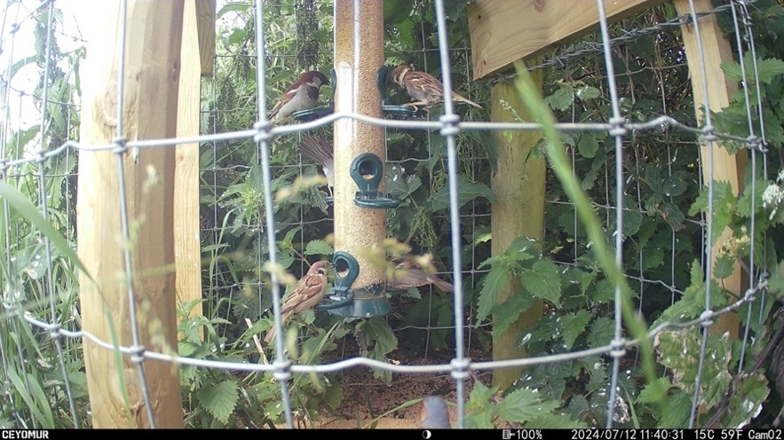
Figure 2 - Two Tree Sparrow feeding on white millet alongside House Sparrows at Ballawhetstone. © MFBRG
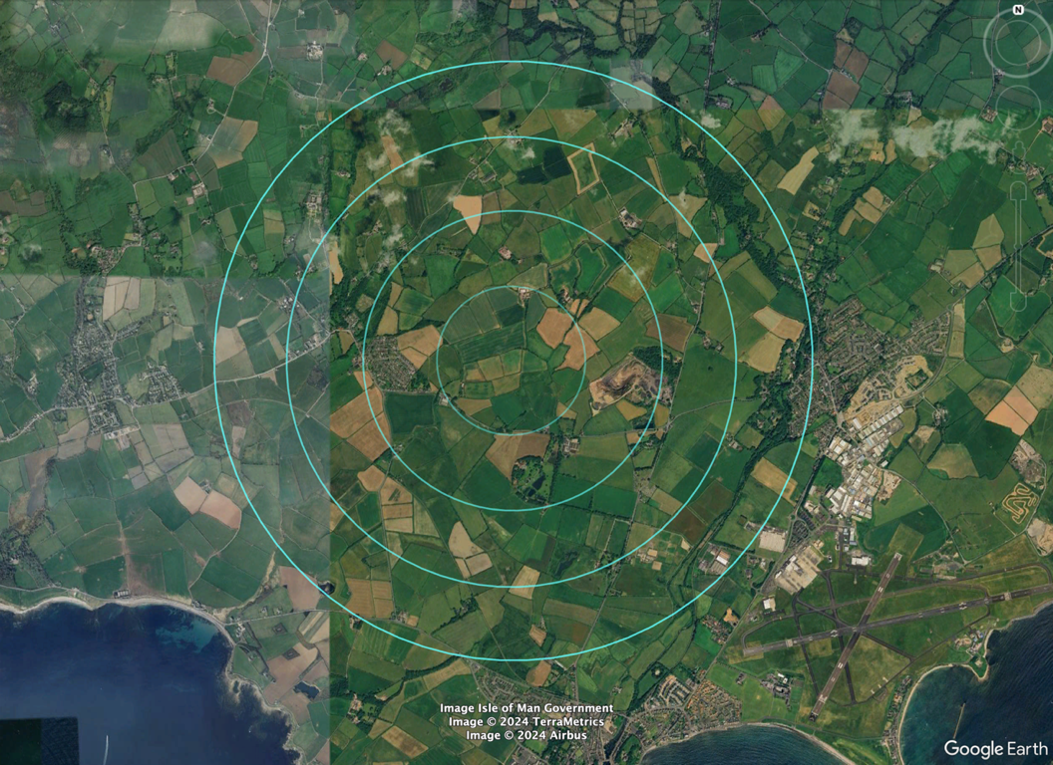
Figure 3 - Map centred on Ballawhetsone, with 500m radius rings denoting the area for focus for Tree Sparrow efforts.
Further seed hoppers (Figure 4) were installed in 2024 within 1km of the already established over-wintering/breeding site to provide extra year-round supplementary food. This will be further expanded throughout 2025 to provide enhanced feeding opportunities.

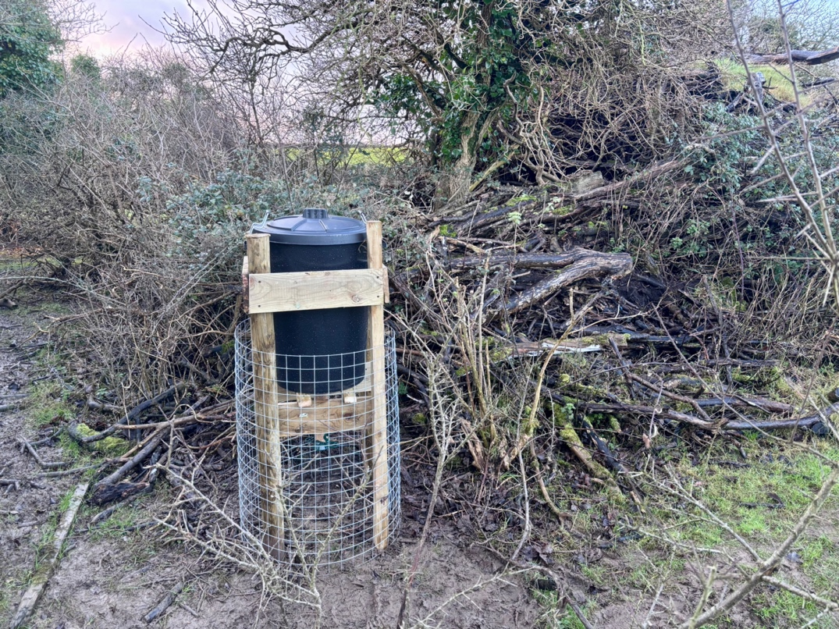
Figure 4 - One of two seed hoppers were installed at the MWT Billown Nature Reserve, 1km of the Ballawhetstone site.

For more information on the Tree Sparrow Project and how you can help please visit: https://www.mwt.im/tree-sparrow

Curlew – Crottag

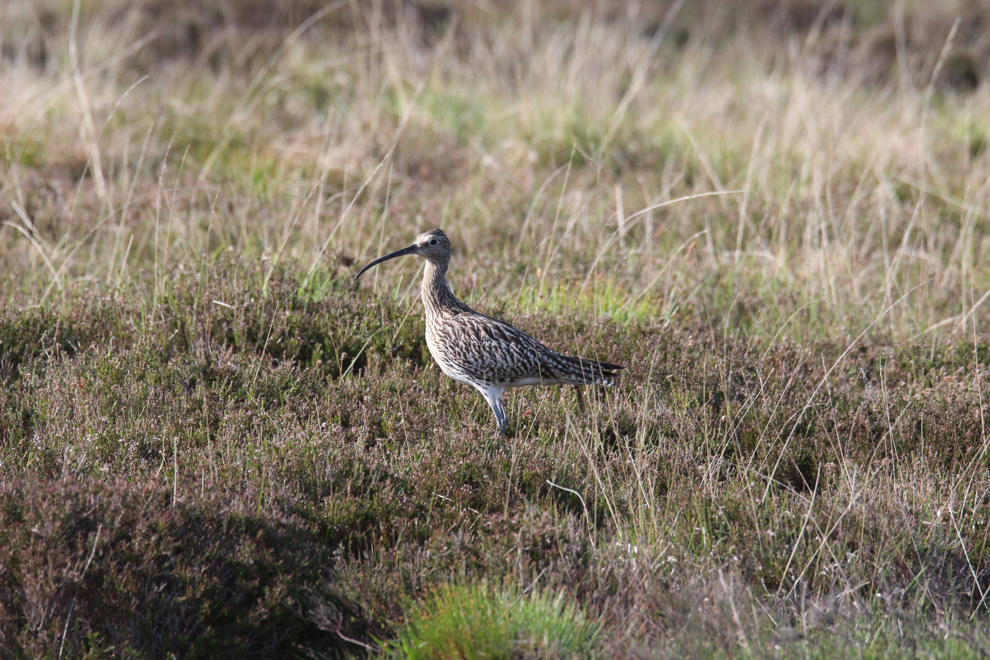
Figure 5 - Curlew in its upland breeding habitat in Glen Rushen. © Robert Fisher.
Curlew are a red-listed, Schedule 1 (specially protected) species which has undergone significant population and range decline on the Island and is considered to be in long-term risk of extirpation as a breeding species without effective conservation measures.

Our Curlew project focused on the Southern Hills and surrounding foothills and more marginal agricultural lowlands where a viable population remains (see Figure 6). This population is centred on the Cross Vein area within Glen Rushen, where the DEFA Upland Ranger has long worked to boost numbers. This is likely the only area of the Island where numbers of breeding pairs has increased.

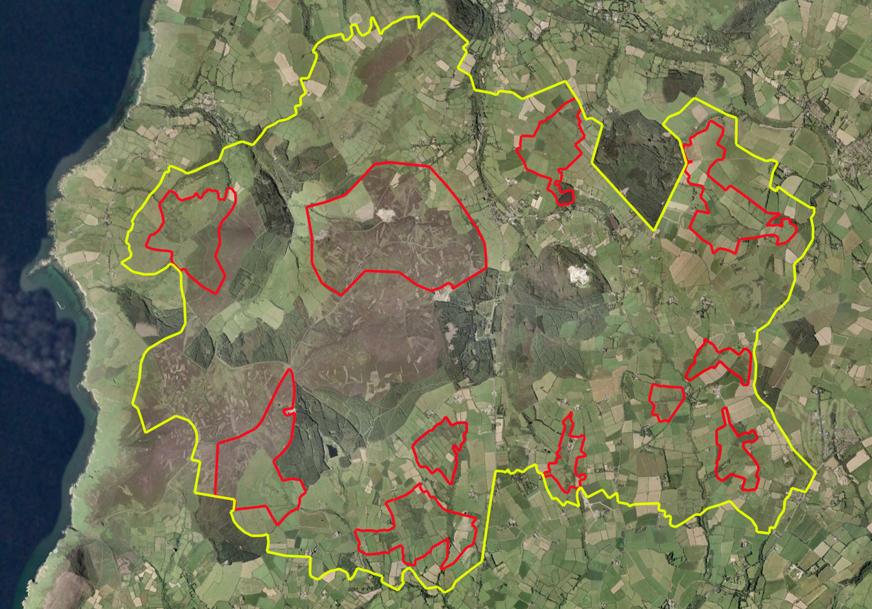
Figure 6 - 'Curlew Country' within the Southern Hills, foothills and nearby marginal agricultural lowlands. Red indicates areas of known Curlew breeding in 2024 (along with associated foraging areas). Yellow indicates the 60km² wider landscape for targeted conservation action, as this includes every known nest south of the Central Valley.
Curlew were heard returning to their upland breeding grounds from mid-March 2024, which coincided with prolonged cold and wet weather. This weather led us to presume that pairs were holding off laying eggs, with adults recorded singing and regularly feeding but with no obvious sign of nesting. After careful observation from a safe distance on Dalby Mountain, a single bird was watched until it was seen to sit down on eggs amongst heather moorland on 12th May. Under DEFA licence, a closer inspection of the area recorded a nest with four warm eggs on 13th May (Figure 7). All four of the eggs successfully hatched the next day, indicating that egg laying had in fact taken place far earlier that was appreciated, with the juveniles leaving the nest site within 36 hours. The young were first seen feeding on adjacent grassy fields on 16th May. Three pairs used this area, with all three nests hatching chicks and at least two juveniles from two broods successfully fledging.

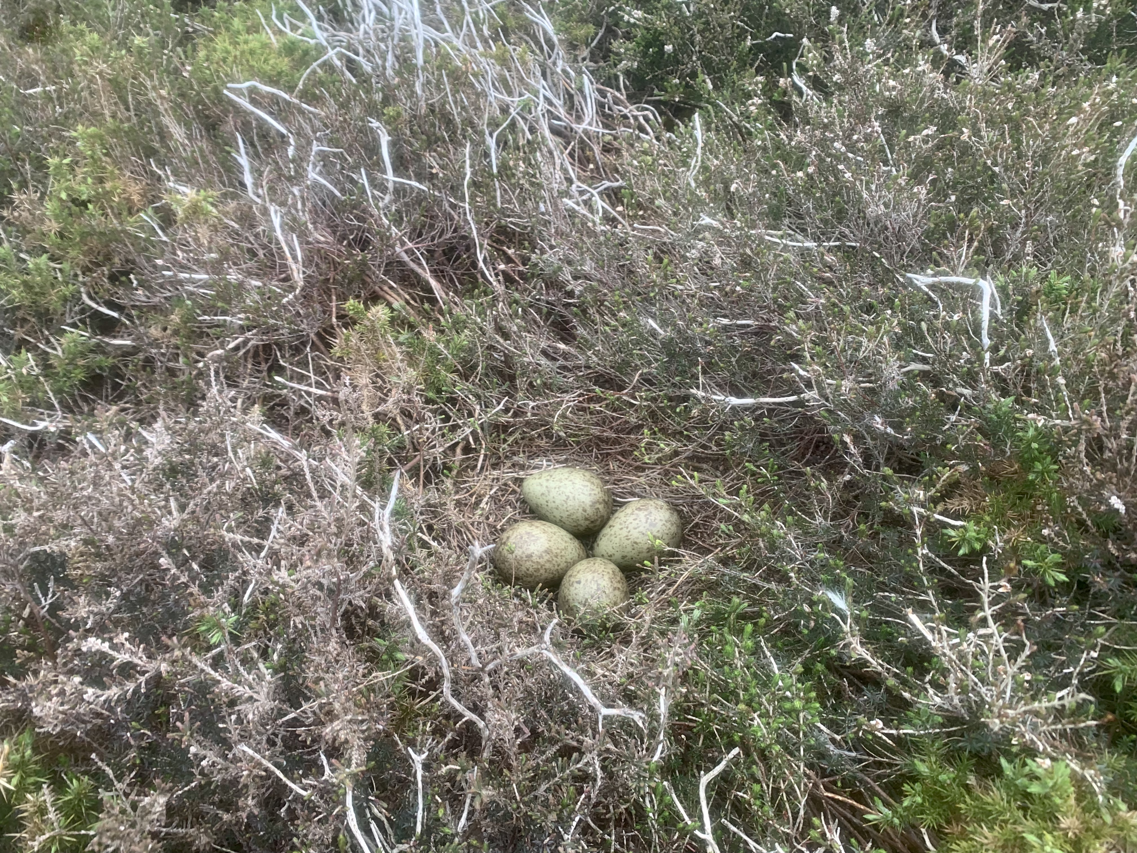
Figure 7 - Curlew nest with four eggs on Dalby Mountain, 13th May 2024. © Robert Fisher
While practical conservation efforts were focused in the Cross Vein & Dalby Mountain areas, an effort was made to locate and map all pairs of Curlew across the whole south of the Island, south of the Central Valley which connects Douglas to Peel. Within this area nicknamed ‘Curlew Country’ (Figure 6), eleven sites have had confirmed or suspect Curlew breeding in the last few years. No breeding Curlew were recorded outside of this area in the whole south of the Island. In 2024, a total of 25 pairs were recorded within ‘Curlew Country’ as follows:
- Cross Vein area: 9 pairs
- Dalby Mountain: 3 pairs
- Foxdale Observatory area: 2 pairs
- Eairy Kelly & St Patrick’s Chair area: 2 pairs
- Ballahowin area: 1 pair
- Ballavarvane area: 1 pair
- Broogh Fort area: 1 pair
- Lower Cordeman area: 2 pairs
- Grenaby Gareys ASSI (northern area, near Balladaniel): 1 pair
- Grenaby Gareys ASSI (southern area, near Moaney Mooar): 2 pairs
- Garey Mooar & Cringle Great Park: no pairs in 2024

North of the central valley, resources did not allow for specific monitoring to be undertaken, however formal records were made of all pairs of breeding Curlew which were observed incidentally or otherwise reported to the group. Sadly, there were no records from the entire east of the Island, including the parishes of Maughold, Lonan, Onchan & Marown.

Aside from ‘Curlew Country’, other key remaining Curlew breeding areas included the Ayres (18 pairs, Louise Samson, pers. comm.), the lowland valleys of German and Michael parishes, upland areas within Lezayre, and generally the wetter areas of the Northern Plain, including the wet agricultural land surrounding the Ballaugh Curragh ASSI.

In total, there are 37 reported/suspected breeding areas outside of ‘Curlew Country’ that have been in use in recent years.

The Manx hills are recognised by BirdLife International and the RSPB as being of international importance for Curlew, recognised as the Isle of Man Hills Important Bird Area. Our survey work in 2024 confirmed that this recognition remains valid.

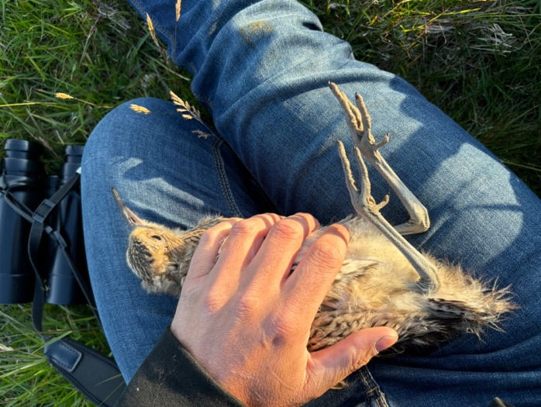
Figure 8 – Curlew chick being ringed (under DEFA & BTO licence) on Dalby Mountain on 19/06/2024.

Lapwing - Eairkan

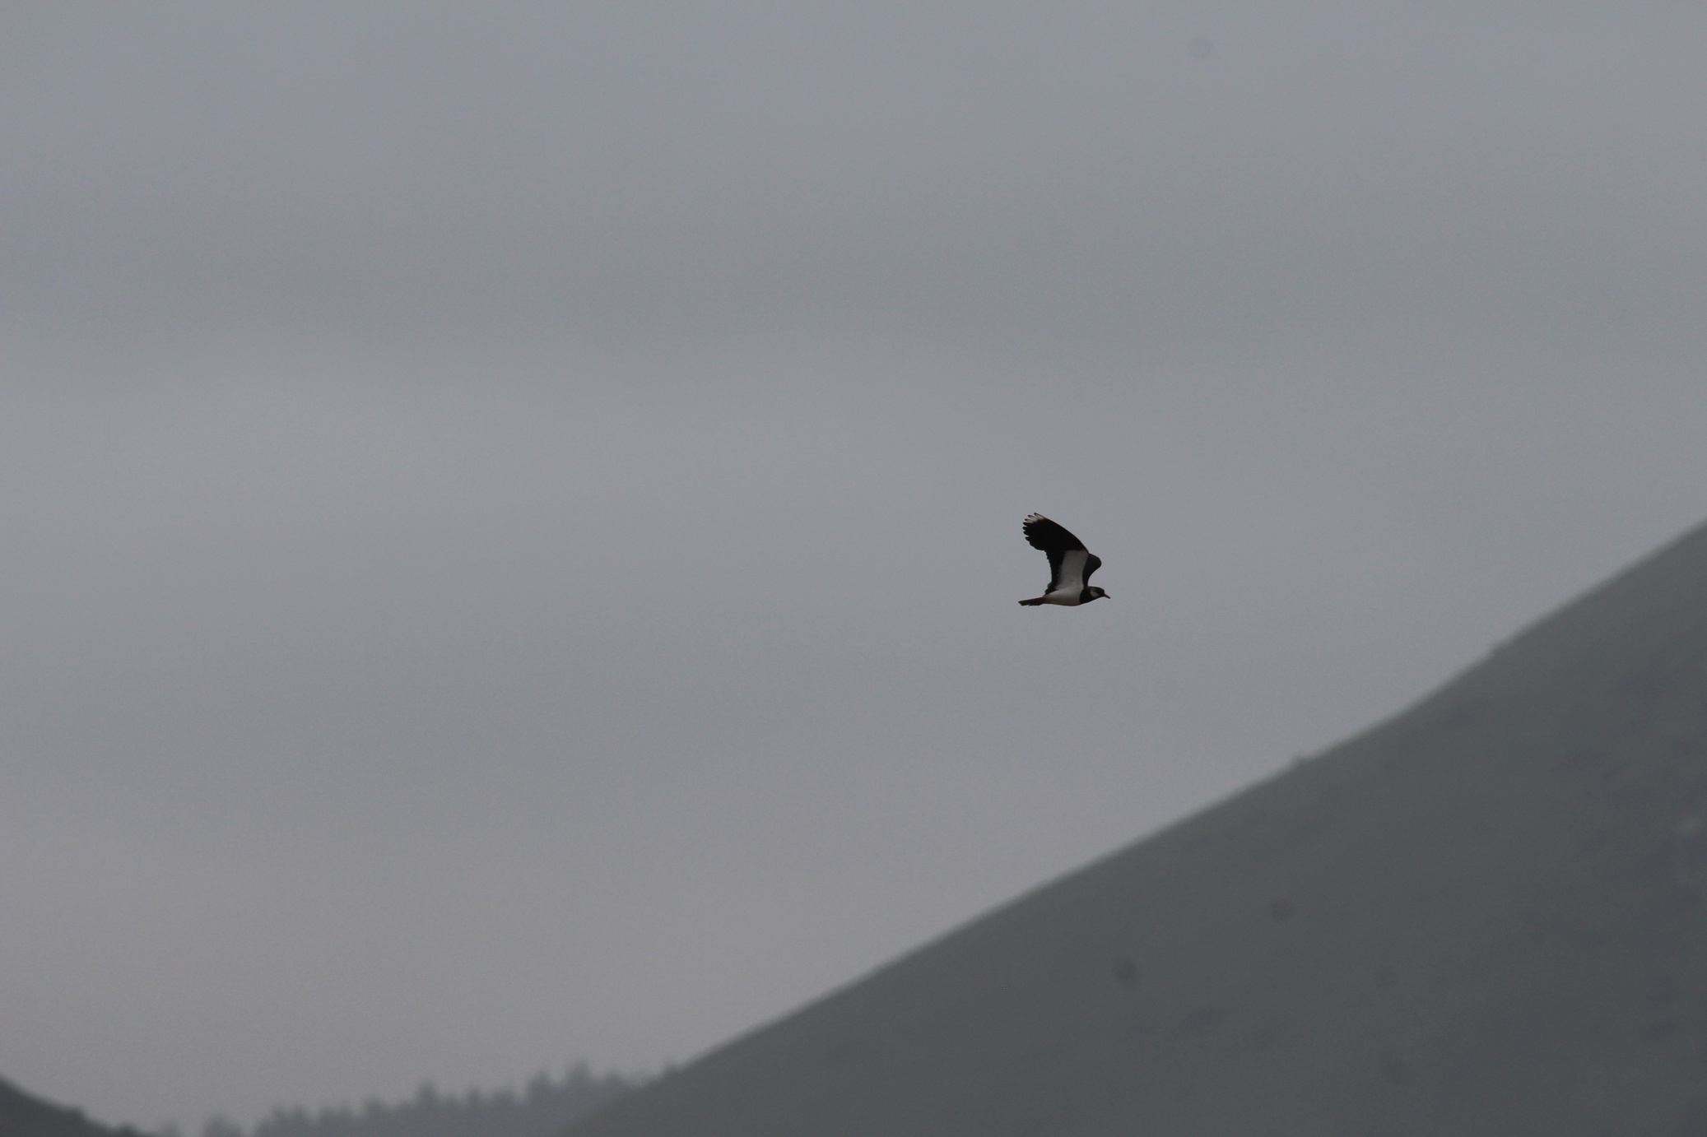
Figure 9 – Lapwing flying over St Jude’s Loops Road, 27th June 2024 © Robert Fisher

Lapwing are a red-listed, Schedule 1 (specially protected) species which has undergone significant population and range decline on the Island. The last confirmed breeding attempt was in 2022 (two pairs, both failed, Kerrowmooar, Sulby). It is considered that this species is now either extirpated as a breeding species or, at best, functionally extinct. Migratory birds still over-winter on the Island however.

A pair of Lapwing were spotted mobbing corvids in early June near to St Jude’s by Adam Denard and Greg Watson of MWT. The site was suitable breeding habitat, with two Curlew and two Oystercatcher also noted feeding in the same field. Of note, Oystercatcher are rarely seen inland in Mann. Furthermore, this site is close to Kerrowmooar in Sulby where the last two known breeding attempts took place in 2022. While breeding was not confirmed, sightings on consecutive days and aggressive behaviour indicates a probable breeding record.

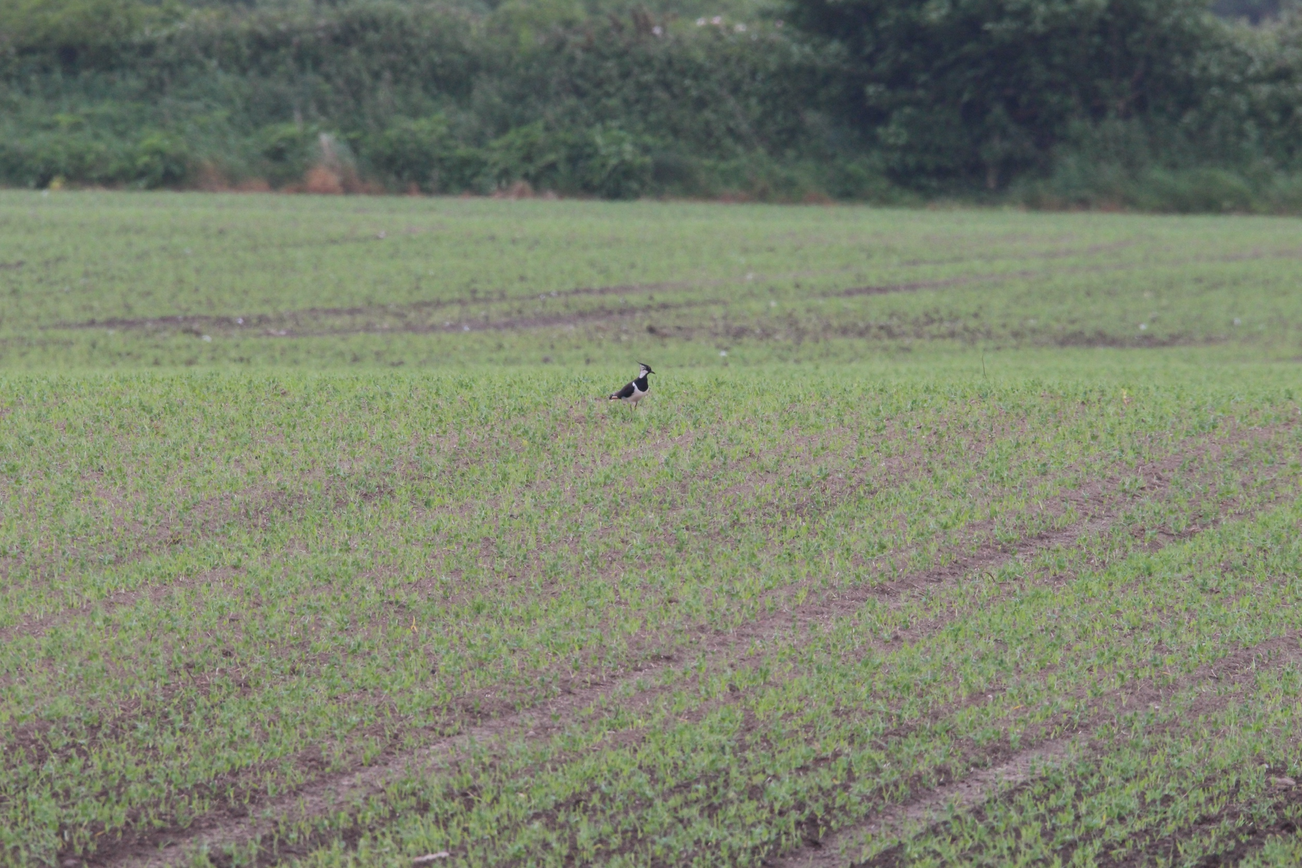
Figure 10 – Lapwing in an arable field near St Jude’s crossroads, 27th June 2024. © Robert Fisher
Chough – Caaig
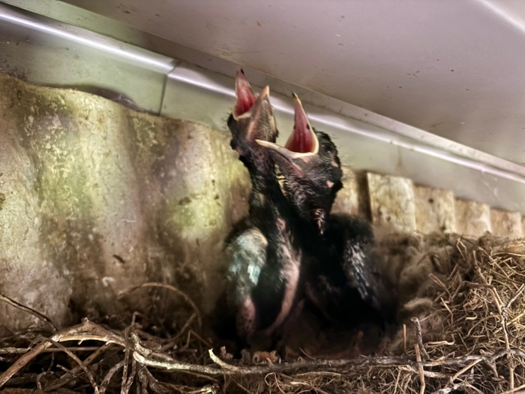
Figure 11 - Chough nestlings in a modern agricultural building surrounded by their ideal foraging habitat, extensive, tightly-grazed permanent pasture.
Chough are an amber-listed, Schedule 1 (specially protected) species which has undergone recent population and range expansion on the Island. The species is not considered to be in any risk of extirpation, however it is a bird of conservation importance owing to the Island supporting an internationally significant population of this species. The Island boasts 28% of the combined UK & IOM breeding population on just 0.2% of the area. Northern Ireland lost this breeding species in 2016. They have also been lost from mainland Scotland, and now remain on only two Islands: Colonsay and Islay. The species is also in decline in north Wales, but stable elsewhere in coastal Wales. The population is also stable in the Republic of Ireland (where the species is amber-listed) and expanding in Cornwall. Re-introduction programmes are underway in Kent and Jersey, notably using conservation grazing with Manx Loaghtan sheep.

Chough naturally build their nests in caves and crevices along the rocky coast, however in recent decades here on the Isle of Man, Chough have also shown a preference for using farm buildings and inland ruins for nesting. This has also facilitated their recent colonisation of the Island’s Northern Plain.

During the 2024 breeding season, owing to the exceptionally poor weather, many Chough either did not breed at all or failed. The Chough pairs that did breed were slightly later than usual. Five pair of Chough were monitored which nested in farm buildings in 2024, with 13 juveniles and 1 adult being fitted with a green darvic colour ring, etched with unique white font alphanumeric combinations to allow monitoring of fledgling survival and post-fledging dispersal. 2024 was the second year that these upgraded rings were used, with the Manx Ringing Group having moved away from the long-used combinations of individually-coloured rings owing to the ease of which the Chough could remove them.
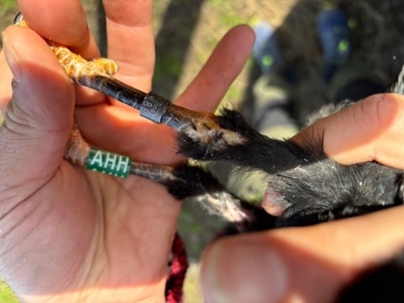
Figure 12 - Juvenile Chough being ringed (under licence) with unique metal and colour identification rings.
Barn Owl - Screeaghag Oie

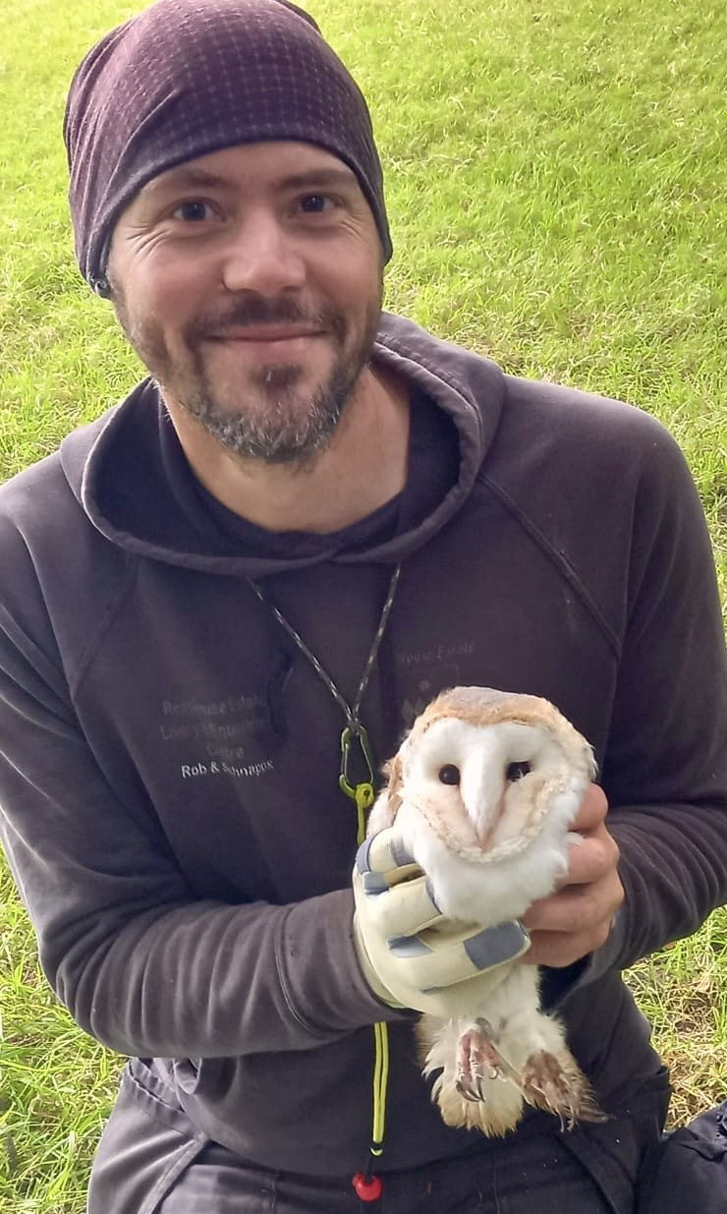
Figure 13 - Adult female Barn Owl ringed (under DEFA & BTO licence) from an active nestbox. © MWT
Barn Owl are a red-listed, Schedule 1 (specially protected) species which has undergone population and range decline on the Island. The Island has likely never supported a large Barn Owl population (noting the absence of their primary food, voles), however the future viability of this population remains in considerable doubt without effective conservation effort for a variety of reasons, including the widespread use of rodenticides which can kill Barn Owls through secondary poisoning.

With only around ten breeding pairs remaining Island-wide, the agricultural Northern Plain is the Manx stronghold of this species. Records were also received from the lowland agricultural areas of German, Patrick, Marown, Santon, Rushen and Arbory parishes. Working with farmers, eight Barn Owl boxes were monitored, resulting in two breeding pairs being located. From these, seven chicks were ringed along with two adults (one from each occupied box). Through the autumn and winter of 2024, twenty Barn Owl nest boxes (built by Robert Fisher to Barn Owl Trust specifications) have been distributed across the Island to give the species protection while roosting and breeding.

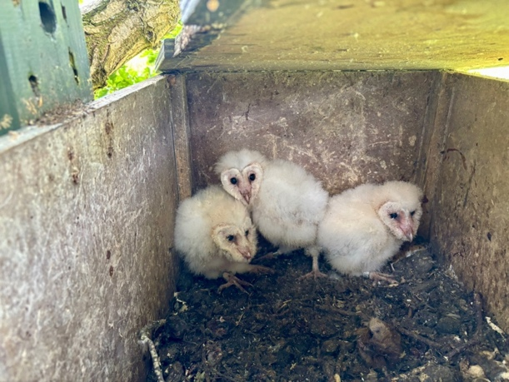
Figure 14 - Barn Owl chicks in the nest after being ringed (under licence). Confidential site. 2024. © Robert Fisher
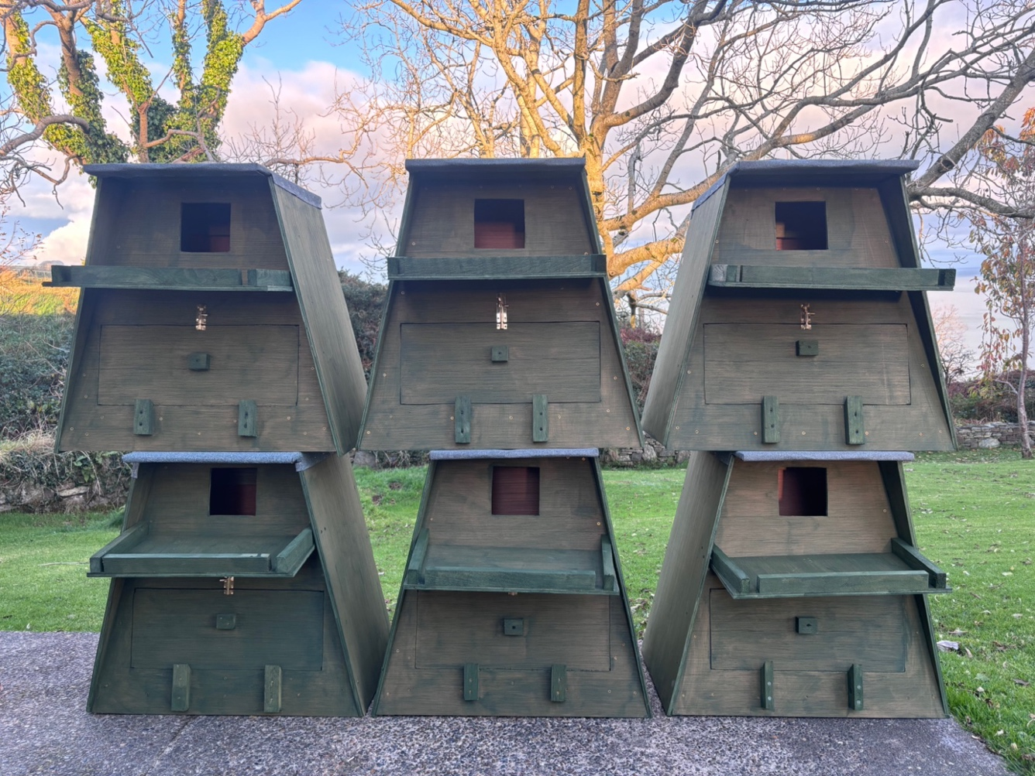
Figure 15 - Six Barn Owl boxes ready for distribution around the Island. © Robert Fisher
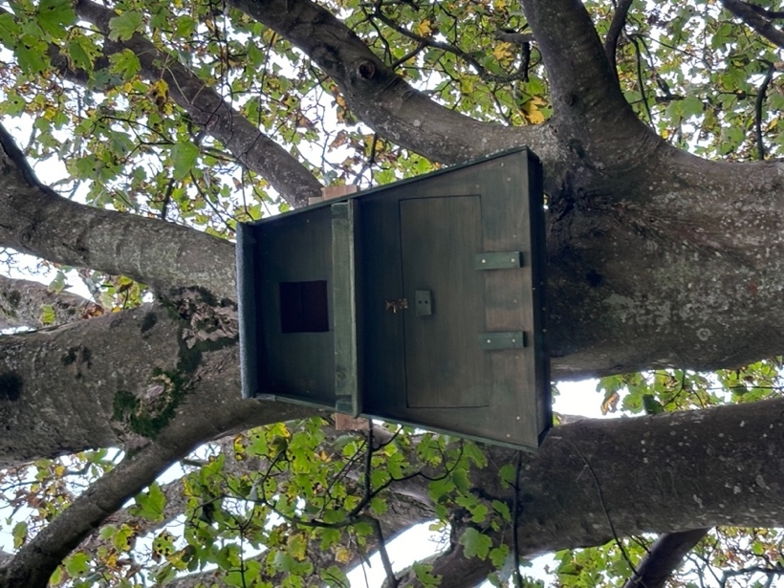

Figure 16 - Barn Owl box installed in a mature Sycamore tree, surrounded by open, rough grassland. Ballaugh. © MWT


Considerable funding from the Curraghs Wildlife Park Conservation Fund has allowed us to expand our Barn Owl project here on the Island. The start of this exciting collaboration was marked by the distribution, for free, of copies of ‘The Book Of The Barn Owl’ by Sally Coulthard to every secondary school and municipal library on the Island.

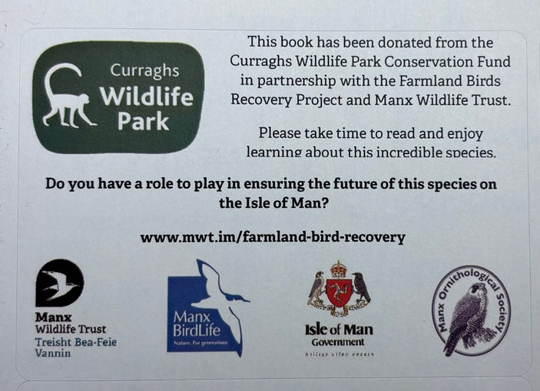
Figure 17 - Insert for each of the Sally Coulthard books.

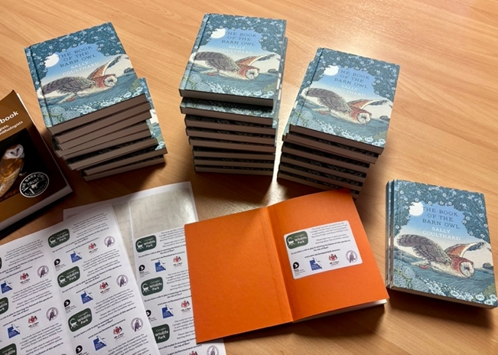
Figure 18 - Books ready for distribution to all municipal libraries and secondary schools on the Isle of Man.

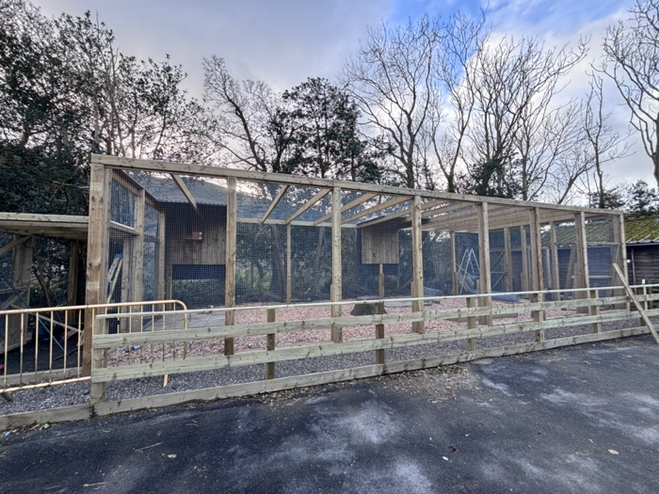
Figure 19 - The Curraghs Wildlife Park’s new Barn Owl enclosure ahead of installation of interpretation covering the Island’s avian conversation projects i.e., Tree Sparrow, Curlew and Barn Owl. © Robert Fisher
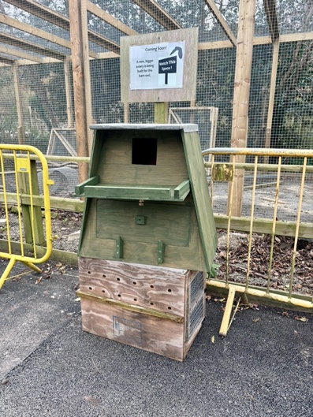
Figure 20 - One of two outdoor Barn Owl nest boxes to be installed around the Curraghs Wildlife Park.
Engagement - Agricultural Shows

As per 2023, a Farmland Birds interpretation and education stand was present at both the Southern District Agricultural Show and the Royal Manx Agricultural Show in 2024. At the former, we were very kindly allowed to join the Manx National Farmers’ Union (MNFU) for the two days and had some great engagement with both farmers and the wider public.

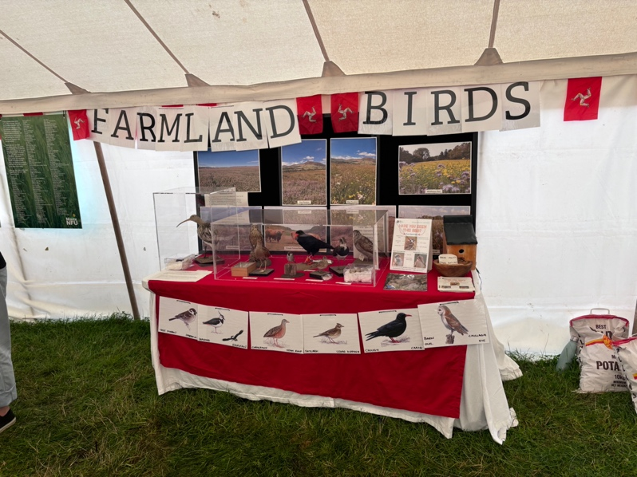
Figure 21 - The display showing our farmland birds work along with taxidermy specimens of key species.
For the Royal Manx Agricultural Show, the Farmland Birds stand was in the Manx Wildlife Trust / Lloyds Bank tent. More great engagement and interesting exchanges of knowledge were had.

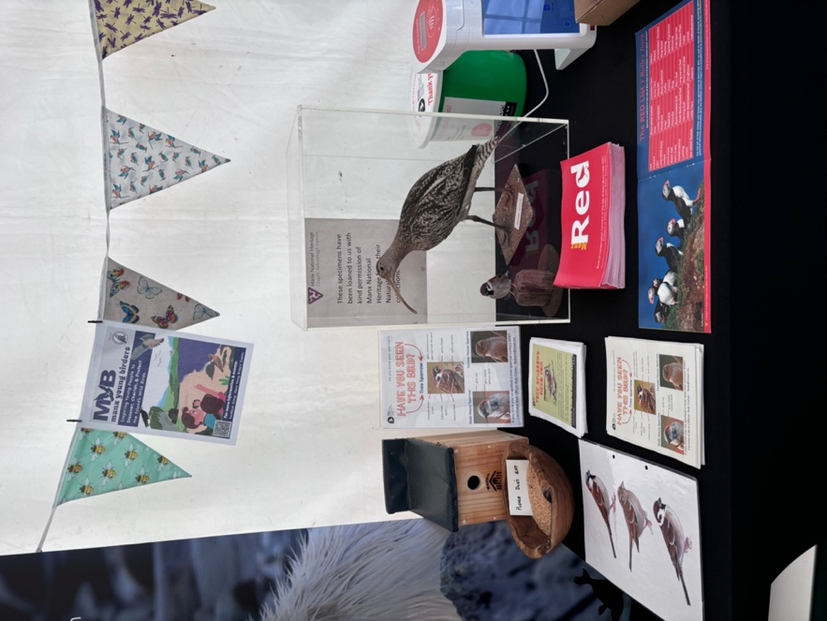
Figure 22 - The Royal Manx Agricultural Show display focusing on the Tree Sparrow and Curlew.

Feedback from two years’ worth of events highlighted these shows to be excellent engagement opportunities, but sadly delivered no results in terms of our aspiration to receive records of Tree Sparrows in the wider landscape. It was great to inform the public of our projects, but conflicted with active conservation and monitoring activity during the breeding season.

Birds which utilise Winter Stubbles

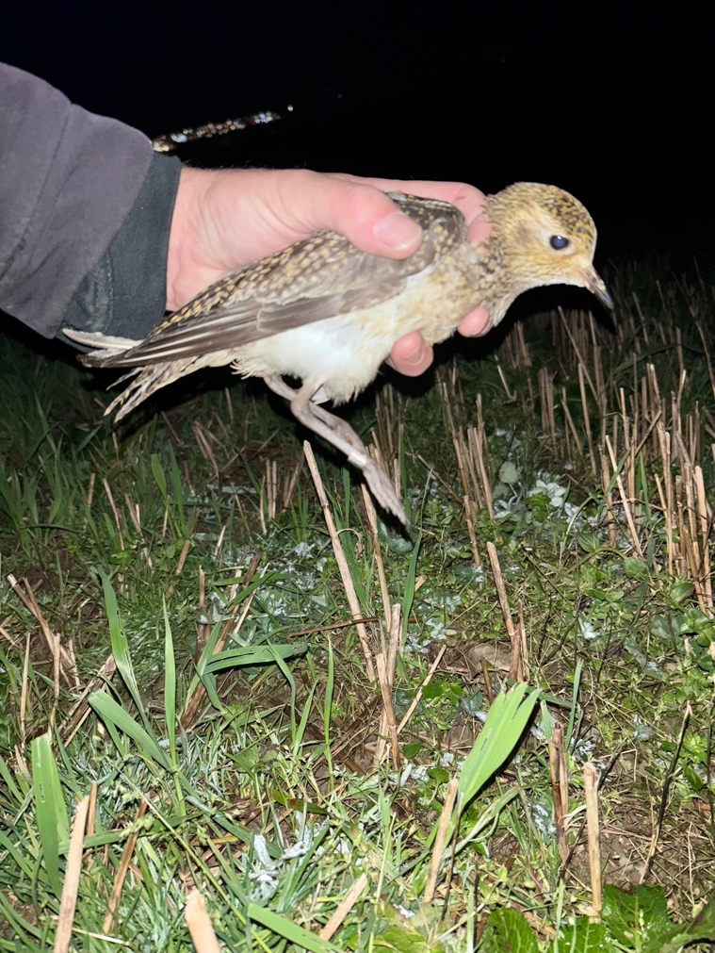
Figure 23 - Golden Plover ringed (under DEFA & BTO licence), Carnane, 22nd November 2024. This was the first Golden Plover to be ringed on the Isle of Man in over twenty years. © Robert Fisher
Winter Stubbles are an incredibly significant foraging (and roosting) habitat for a wide range of farmland birds including (colour indicated Manx conservation status): Skylark, Meadow Pipit, Tree Sparrow, Linnet, Stock Dove, Lapwing, Woodcock, Jack Snipe, Redwing, Reed Bunting, Greenfinch, Goldfinch, Chaffinch & Golden Plover.

The amount of arable (and therefore stubble) area continues to decline on Island. Furthermore, many stubble fields may not provide effective foraging opportunities owing to their intensive management (including spraying or under-sowing). Winter stubbles are financially supported by the DEFA Agri-Environment Scheme, however this year saw an unwelcome reduction in the maximum payment rate from £58/acre to £40/acre. It is hoped that our research will highlight to DEFA Agriculture staff, and the farming and birdwatching communities, the ornithological importance of these transitory habitats.

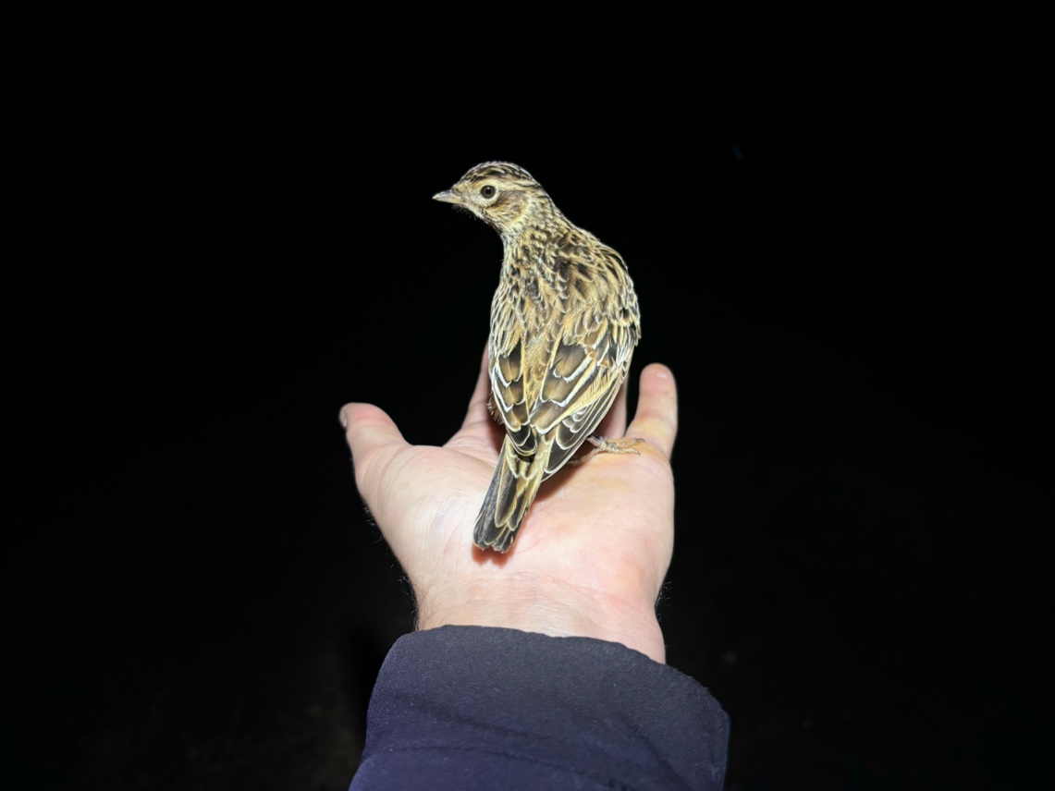
Figure 24 - Skylark ringed (under DEFA & BTO licence) on winter stubble. © Robert Fisher

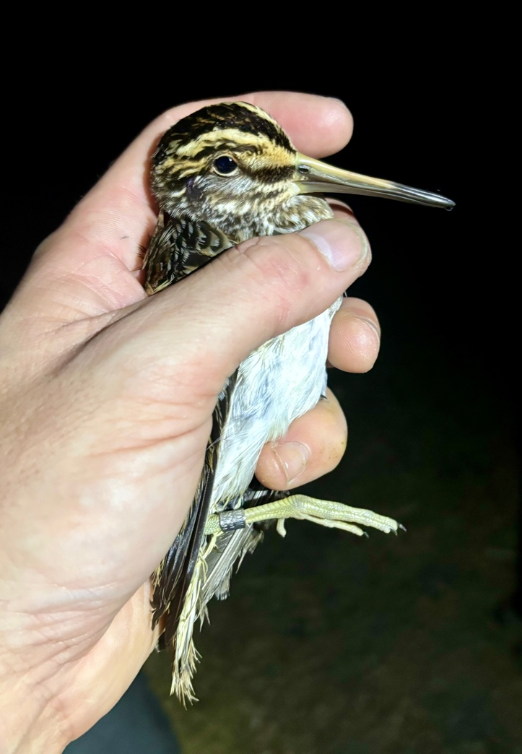
Figure 25 - Jack Snipe caught and ringed (under DEFA & BTO licence) in a very wet stubble field. © Robert Fisher

Sensitively managed winter stubbles, supported by the DEFA Agri-Environment Scheme are amongst the most important habitats to allow many farmland birds to survive the ‘hungry gap’. While giving a Farmland by Night ringing demonstration to the Manx Ornithological Society in November 2024, two Jack Snipe were ringed along with seven red-listed Skylark. Over the autumn and winter 2024/25, 43 Skylark have been ringed on the Island’s stubble fields, helping us get a better understanding of the birds over-wintering habitat preference and total population.

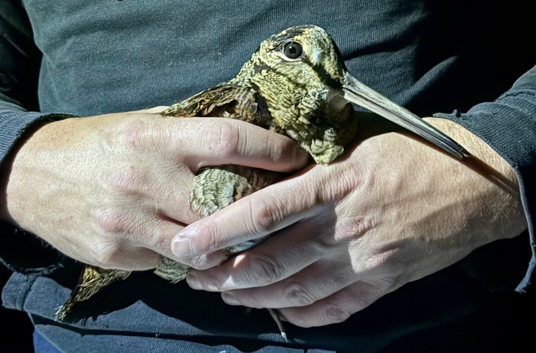
Figure 26 - Woodcock caught and ringed (under DEFA & BTO licence) on winter stubble. © Robert Fisher
Conclusion

After two years of targeted monitoring and active conservation of our farmland birds, we now have a better understanding of the species that are struggling the most, what they need from us, and where best to undertake specific (and often urgently required) conservation interventions.

We now have a baseline knowledge of their population, distribution, requirements and habitat preferences against which to monitor our impact going forward.

As the start of 2025, we know far more about the current status of the Island’s precious and enigmatic farmland birds, which will be enhanced further during 2025 by the Manx BirdLife all-Island Chough Census later this year.

Our farmland birds are sentinels to the health of our agriculturally-dominated landscape. By all conservation organisations working effectively together, and collaborating with our farming community, it is hoped that we can prevent any further extirpations of farmland specialist species on our Island, and in time, bring about a recovery of our farmland birds through more nature-positive arable and pastoral agriculture.

Robert Fisher
Farmland Birds Recovery Officer
Manx Farmland Birds Recovery Group

24th January 2025

With special thanks to all the generous private individuals and organisations who
have so kindly funded and supported our work in 2024. Gura mie mooar ayd!



